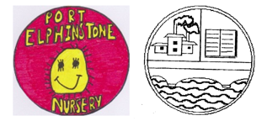
YOU CAN FIND OUT IF SCHOOL / NURSERY ARE OPEN OR CLOSED BY USING ONE OF THE FOLLOWING METHODS:

- ABERDEENSHIRE COUNCIL WEBSITE
Please go to the Aberdeenshire Council website and go to School Closures for the latest information:
http://www.aberdeenshire.gov.uk/closures/
You can subscribe to alerts – please see the website for further details.

- SCHOOL TELEPHONE INFORMATION LINE
(Note that this is an 0870 service and charges are slightly higher than normal. However there is no queuing and an adverse weather call should last less than 1 minute.)

Dial Aberdeenshire Council’s access number – 0870 054 4999 then enter Port Elphinstone School & Nursery pin number – 022430
A message will be left on the option called “adverse weather” so please listen for the latest information.

- RADIO ANNOUNCEMENTS
Regular announcements of school closures are made on Northsound 1, Northsound 2, BBC Radio Scotland and NECR.

- FACEBOOK
There will be a message on the Facebook Page, “Port Elphinstone Primary School & Nursery” if school / nursery are closed.

. . . . . . . . . . . . . . . . . . . . . . . . . . . . . . . . . . . . . .

PLEASE DO NOT PHONE SCHOOL

THANK YOU FOR YOUR CO-OPERATION.

Mrs N Boyle
HEAD TEACHER

