Port Elphinstone School & Nursery
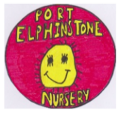
NEWSLETTER

Tel No. 01467 536860 Email – portelphinstone.sch@aberdeenshire.gov.uk
School Information Line – 0370 054 4999 Pin number – 022430
Facebook Page – Port Elphinstone Primary School & Nursery
HEAD TEACHER Mrs N Boyle B.Ed.

DECEMBER 2019
Dear Parents/Carers
This term is quickly disappearing – it is not long till the Christmas holidays! I’d like to update you on several items of information.

Adverse Weather
Can I remind parents that the website and phone line will only be updated if the school is closed and will not be updated if the school is open - if there is no message, then it is a normal school day. There will also be a message on Facebook. Please ensure you check the adverse weather website before sending your child to school on snowy days that school is open.
If P1-7 pupils are not at school, it is expected that they will continue with their reading book, practising tables, number facts, or other activities as outlined in the School Closure Activities sheet that went home recently.

Christmas Jumper / Accessories day
Friday 13 December is Christmas Jumper & Accessories day! Pupils can come to school in non-uniform and wear their festive clothes and accessories. There is a charge of £1 and the money raised will go to the charity “Save the Children”. Thank you.
Christmas Singalong
We are having a “Christmas Singalong” on the last day of term, on Friday 20 December, starting at 3pm. Nursery children and P1-7 pupils will be taking part: All parents are welcome to come along and sing with us. We will be singing outside in the infant playground.

Illness
Recently we have had quite a few children off due to either a sickness bug or a sore head/cough/high temperature type illness. Please remember not to put your child to school if they are ill as this may spread their germs to others unnecessarily. If your child has sickness and / or diahorrea they must stay off for 48 hours after the symptoms have stopped. Thank you.
Christmas Parties
Just to inform you that on party day for P1-7 pupils, they can either go home for lunch (12:30 – 1:30) or take their party clothes in a bag to change during lunchtime. The party is held in the hall from 1:30 – 3:25. The pupils play some party games and have some party food. There may also be a visitor at the Nursery party and P1-3 party…?? Ho Ho Ho!!
NURSERY WED 18 DEC 1:00 – 4:00
P1-3 MON 16 DEC 1.30 – 3:25
P4-7 THURS 19 DEC 1:30 – 3:25
This Photo by Unknown Author is licensed under CC BY-SA-NC

Pupil Christmas lunch
The pupils had a great Christmas lunch on 4 December! Thank you to Frances Matheson who donated the crackers for all the pupils.

Speed / Parking Issues
It has been brought to my attention that there are still issues with cars driving beyond the speed limit around school. Please note that the speed limit is 20mph and this is to ensure the safety of pupils, parents, staff and residents. Parking is very limited so if it is possible then please choose to walk to and from school / nursery. Please remember to REVERSE PARK if possible. Thank you for your cooperation.
Panto trip to HMT P1-7 pupils
Please ensure that you have returned the form regarding pick up on the day of the Panto. If you need another form, then please get in touch. If your child is being picked up by another adult, then make sure to let us know.
Thank you.

School security
Please remember to enter the school by the front door only, where the security system is, and to sign in and wear a visitor’s badge if you are in for any length of time. If you are only in to pass a message or an item on e.g. a lunchbox, then this can be done via any member of staff. If you require to speak to your child’s teacher, then please remain at the reception until the teacher can be found. Many thanks for your co-operation in maintaining school security.

Parent Council News
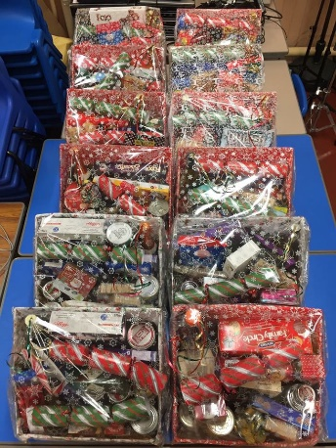
Thank you to everyone who supported our Christmas Coffee Morning event on Saturday 30 November. We raised £630 which will help support the school and benefit all the pupils. Thank you so much to everyone who donated towards our stalls, and to Nicola Kinnon who donated the mince pies and stollen for the event.
We hope that you will be able to sell as many lucky squares tickets as possible for the Christmas Hampers. Hamper donations and money should be handed in this week.
Our next meeting will be on MONDAY 13 January at 6pm – this is a change of date to what was organised previously.

Notes
Can I please remind parents that it is pupil’s responsibility to hand in notes to the teacher and to ensure that notes handed out at school are taken home. If you feel that your child may forget to hand in notes, then please hand them in at the school office. Staff do not have time to check inside reading bags and schoolbags of all pupils for notes. Thank you for your cooperation.
DATES FOR YOUR DIARY
Tues 10 Dec 9:45am P1-7 SCHOOL SHOW
Tues 10/Wed 11 6:30pm P1-7 SCHOOL SHOW
Fri 13 Dec Christmas Jumper day
Mon 16 Dec P1-3 Christmas Party 1.30-3:25
Tues 17 Dec P1-7 trip to HMT to see Panto (CINDERELLA)
Early lunch 11:45, leave school 12:30 &
back at school approx 5:30pm
Wed 18 Dec Nursery Party 1-4pm
Thurs 19 Dec P4-7 Christmas Party 1:30-3:25
Fri 20 Dec Nursery & P1-7 Carol Singing 3pm
Infant Playground – Everyone welcome
Fri 20 Dec School closes for holidays at the usual time.
Mon 6 Jan 2020 Back to School / Nursery
Mon 13 Jan Parent council Meeting 6pm
Mon 27 Jan P1-7 Scots Poetry Final 2:00 Everyone Welcome
Thurs 13 Feb NO SCHOOL / NURSERY – Holiday
Fri 14 Feb NO SCHOOL / NURSERY – Holiday
Mon 17 Feb NO SCHOOL / NURSERY – Holiday
Tues 18 Feb NO SCHOOL / NURSERY – Inservice training for staff
Wed 19 Feb NO SCHOOL / NURSERY – Inservice training for staff

Fri 3 April School closes for holidays at the usual time.

* * * * * * * * * * * * * * * * * * * * * * * * * * * * * * * * * * * * * * * * * * * * * * * * * * * *
Please feel free to get in touch if you would like to discuss any matter further.
You are invited to comment on the return pro-forma on any aspect of school whether as a comment/suggestion, compliment or concern. These are responded to as and when necessary. Please print and return the slip or respond to this email. Thank you.
Yours sincerely

This Photo by Unknown Author is licensed under CC BY-NC

Mrs Nic Boyle
Head Teacher

Comment / Suggestion, Compliment or Concern

………………………………………………………………………………………………………………………………

………………………………………………………………………………………………………………………………

………………………………………………………………………………………………………………………………

………………………………………………………………………………………………………………………………

………………………………………………………………………………………………………………………………

………………………………………………………………………………………………………………………………

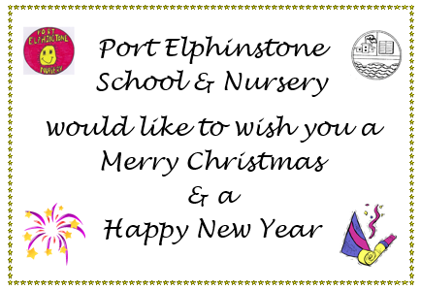
Signature …………………………………………………………………………………………… December 2019

