WELCOME TO

PORT ELPHINSTONE
SCHOOL NURSERY
2022-2023

Contents Index

Page Number

Important Information 5

Staff 5

Introduction 6

Nursery Hours 6

Nursery Induction 7

Aims 8

Curriculum 9

Partnership with Parents, Other Partnerships 10
and Transition

Health and Safety 11

Emergency Closure Procedures 12

Nursery Snack 12

Clothing 13

Cloakroom Procedure 13

Policies, Inspection Report, Complaints
and Child Protection 14

Term Dates 15

Important Information

School Address: Port Elphinstone School
School Road
Port Elphinstone
Inverurie
AB51 3XJ

Telephone: 01467 536860
Email: port.elphinstone.sch@aberdeenshire.gov.uk

Staff

Head teacher Amelia Davies

Early Years Senior Practitioner Julia Hutcheon

Early Years Lead Practitioner Paula Cameron

Early Years Practitioners Wendy Kelman, Kirstin Stewart, Lisa Grieve

Administrator Karen Taylor

Admin Support Yvonne Donald

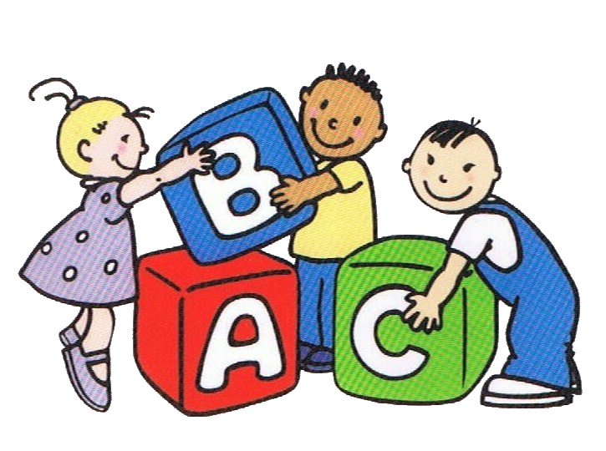

Introduction

Port Elphinstone Nursery School is a purpose-built nursery which opened in August 2000. It is situated adjacent to Port Elphinstone Primary School. There is a large parkland to the rear and side and an enclosed outdoor area for the exclusive use of nursery children. We have morning and afternoon classes with mixed aged children between 3 and 5 years old. We have a maximum of 16 places for pupils in each session. Since August 2019 we have been offering full day sessions.

Nursery Hours

The Scottish Government are committed to providing an increase in entitlement to Early Learning and Childcare for all 3- and 4-year-olds, and eligible 2 year olds, from 600 hours to 1140 hours, per annum, by August 2021.
1140 hours of funded Early Learning and Childcare at Port Elphinstone ELC works out as:
30 hours a week (6 x 5-hour sessions or 3 x 10 hour sessions) over 4 school terms.
This could be:
- Daily session blocks, of 5 hours each, would be available from 8 am – 1 pm and 1 pm to 6 pm with flexible soft am start and pm end. However, core hours will apply within these times and will be 8.45am – 12.45am and 1pm - 4.10pm. These hours apply if you would like to continue with the 600 hours entitlement.
- Parents may have the option for their child to be in Nursery some days from 8 am – 6 pm to a total of 3 full days. This may better suit parents who are working.
- The early years setting will be open term time and closed during all school holidays, local holidays and in-service days.

Am Session I PM Session
Session Times: | Drop off | Pick up | Drop off | Pick up
Extended hours 1140+hrs/yr | 8:00 or 8.50-9:00 | 12:45 | 13:00 | 17:00-17.45
Core Hours 600hrs/yr | 8:50 | 12:45 | 13:00 | 16:10
Full Day = 2 sessions | 8:00 or 8.50-9:00 | 16:10 | or | 17:00-17.45

For children who attend nursery in the morning there will be a free lunch provided, which is served in the school dining hall. In the afternoon at 3.30 we are serving a substantial snack. Both meals and fruit/vegetables are provided and paid for by Aberdeenshire Catering Services and no contribution is required from families.

In the interest of safety, all children must be brought to school and collected from school by an adult. Parents should inform the school if someone different is going to pick up their child on a specific day. There is usually opportunity at the start and end of the session to talk to nursery staff. You will be asked to sign your child out at the end of the session.

Nursery Induction

All parents are invited to bring their child to visit the nursery at an arranged date before they begin Nursery. At that visit, there will be an opportunity for the children to play in the nursery and to meet staff and classmates. Staff will be available to talk to parents.

At the beginning of the school term in which pupils begin Nursery, pupils will be phased into nursery in small groups, to allow staff, pupils and parents to become acquainted. This will encourage a sense of security and confidence in pupils at this exciting new time in their lives.

Through the Early Years Curriculum, the staff strive to develop and broaden the range of the children’s learning experiences, to leave them confident, eager and enthusiastic learners.
Port Elphinstone School and Nursery Aims

Getting it Right for Every Child
Port Elphinstone School Aims

Getting it Right for Every Child

Confident
Individuals
Responsible
Citizens
Honesty

- Tell the truth
- Promote positive relationships
Effective
Communicators

Successful
Learners
Teamwork

- Working in partnerships
- Supporting each other
- Work together to promote a positive ethos

Respect

- Respect for all
- Everyone has a voice
- Caring for the world around us
Inclusion

- Respect diversity
- Every child is supported to achieve their full potential
- Support children to overcome inequalities
Working together to achieve the best for all children and equip them for lifelong learning in a safe and nurturing environment
Responsibility

- Provide a safe, stimulating and challenging learning environment
- Children are encouraged to have an active role in their learning

Fairness

- Opportunities for all
- To nurture the health and
well-being of every child
- To promote resilience

Nursery: The Curriculum

Port Elphinstone Nursery follows the “Curriculum for Excellence” produced by Her Majesty’s Inspectorate of Schools. The curriculum centers around four main capacities.

Children are encouraged to be:

- Successful learners
- Confident individuals
- Effective contributors
- Responsible citizens

These capacities are taught through 8 main areas.

- Expressive Arts
- Health and Wellbeing
- Literacy and English
- Mathematics and Numeracy
- Science
- Social Studies
- Technologies
- Religious and Moral Education. *

Children in the Nursery will access the Early Years section of the curriculum and this will continue into primary one. For further information please refer to http://www.educationscotland.gov.uk

The Scottish Government’s desire to ensure that we strive to “Get it Right for Every Child” (GIRFEC) means that at our nursery we will be ensuring that all experiences and development milestones for your child will be measured and recorded within the SHANARRI (Safe, Healthy, Achieving, Nurtured, Active, Respected, Responsible, Included) wellbeing wheel.

With this in mind Port Elphinstone Nursery have created Learning Journey Folders which reflect your child’s progress with in these SHANARRI categories.

We endeavor to guide the children to have an awareness of what it feels like to be Safe and Healthy. We celebrate their successes when they Achieve personal milestones and create a Nurtured feel within the nursery. As the children grow in physical independence, they learn the benefits of being Active and Responsible for assessing risk within their environment. Showing an awareness of Respect for each other and ensuring everybody is Included in play, are important values in Nursery.

* Religious education has a statutory position in Scottish education, relating to schools but not to Early Learning and Childcare Centers.
Partnership with Parents

Staff work hand in hand with parents to promote children’s learning. The school aims to build on the valuable learning which takes place at home. In normal times, parents will be invited to spend time with the children in the nursery, help run the nursery library, accompany us on trips or do some nursery gardening. We are very keen for this to be reintroduced, when we are given the clearance.

Learning Journey folders are available in the nursery at all times for you to look at with your child and see their progress. Opportunities will be made available termly for parents to visit nursery, Covid restrictions allowing. In March staff hold interviews with parents to discuss children’s progress and development. This was done in a well-ventilated area last year. Parents should be assured that they are welcome in the nursery grounds at any time, whether it be to talk to staff or to access their child’s folders and progress file, or to meet with the Early Years Senior Practitioner or Head Teacher.

Your child will receive termly newsletters keeping you up to date with information and events taking place within the nursery and school. General information can be found on our nursery and public notice boards within the nursery building. This is updated on a regular basis. Communication can be done electronically by email, text or Seesaw, an interactive diary application.

Other Partnerships

We have good working relationships with many agencies. Sometimes it is necessary to work as a team with other professionals such as speech therapy, health visitor, occupational therapist, English as an additional language teachers and education psychologist to give your child the best possible start within our Early Childcare and Education Centre. Please discuss with us if you have any concerns.

Transition

Going into Primary 1 is another big event in your child’s life. We aim to make it a smooth transition. The Nursery at Port Elphinstone is very much part of the school. During Term 4, the nursery pupils who are enrolled for our school will visit the Primary 1 class, meet their buddies and new teacher as part of our extended transition programme. Teachers from other schools will be invited to visit the nursery to see and to share information about pupils transferring to their Primary 1 class. (this was not possible during Covid guidance restrictions)

Health and Safety

The school and Nursery work very hard at creating a safe environment for the children, therefore no vehicles or dogs are permitted within the school grounds.

On a daily basis, in line with Covid guidance, we have decided to only permit children into the Nursery grounds. Parents are asked to wait with their children, at the yellow gate, for nursery staff to come and welcome the children into nursery. This also applies at pick up, we shall bring the children out to you. Please remember to tell us who is picking up your child at the end of the session. If there are any changes then phone the school number 01467 536860. If you are phoning out with school hours, then you can phone the direct line to nursery 01467 532584. Just to remind you that the children are not permitted to open the gate, even if a parent is present.

There is a security entry system in the main school building which is controlled from the office. The Nursery has a secure door with 2 door handles. The buzzer is on the left side of the door which is accessed with a pole.

The nursery should be kept informed about any child’s health problems e.g. allergies, need for inhalers or other medication. A spare inhaler must be kept in Nursery if your child has been diagnosed with Asthma. If staff are required to administer medication, a consent form must be completed and children must have taken the medicine before it being left at nursery. Please ask a member of staff for a form if required.

If a nursery pupil is absent, a parent/carer should inform the school in writing/email or by telephone. If your child has had sickness and/or diarrhea, you must allow a clear symptom free 48 hours before sending them back to Nursery.

If your child should become ill at Nursery, we will phone you without delay. If you are not available, we will phone the emergency contact number you have given us.

It is vital that the school is kept up to date with:

- change of address or phone number
- place of employment and phone number

- emergency contact’s address and phone number
- list of people who are permitted to collect your child
Emergency Closure Procedures

In the rare event of the school being closed, parents will be informed by telephone and asked to collect their child. Should the weather be particularly stormy, and roads snowbound, parents should listen to the radio where school closure announcements are sometimes made, as follows:

- Northsound
- BBC Radio Scotland
- North East Community Radio

Please check Aberdeenshire Council website where up to date information will be displayed: www.aberdeenshire.gov.uk/closures

There will also be a message on the Schools information line: Emergency Information Service telephone number is 0870 054 4999
Pin Number 022430

The school also has a Facebook page – Port Elphinstone Primary School.

Nursery Snack/Meal

A healthy snack/meal is provided daily with either milk or water to drink. In the morning at 9.15 we offer the children breakfast type food (cereal/toast/bagel) with a selection of fruit. Children enjoy helping with its preparation. Their next meal is lunch which is served by nursery staff in the lunch hall in the school. Dietary requirement is catered for and vegetarian meal are provided. Please inform the school if your child has any dietary requirements or allergies. The nursery termly menu for fruit and meals is available on the Aberdeenshire website.
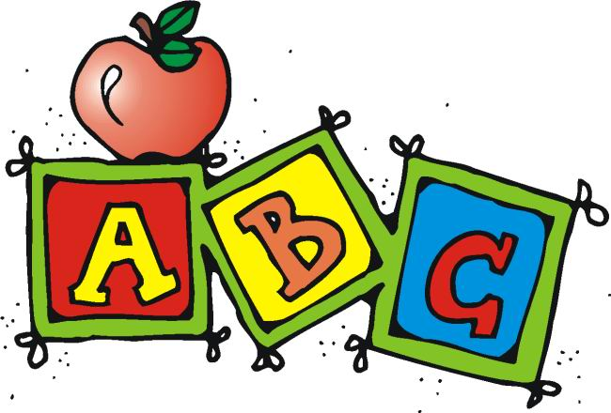

Clothing

Comfortable and practical clothing which is easily managed by the pupil in the cloakroom and toilet, is recommended. The red nursery sweatshirt and yellow nursery t-shirt, bearing the logo is available to order from the school office.

Children also require a pair of shoes for indoor play (crocs, slippers, lace up shoes are not suitable). Painting aprons are provided by the nursery.

As learning about the outdoor environment at first hand is a fundamental part of the nursery curriculum, the children are regularly involved in outdoor play and walks within the local area. Children therefore need to be dressed appropriately for the weather conditions.

Please help staff by ensuring that all items of nursery clothing are clearly named. It is also important that children do not wear lacing shoes to Nursery unless they are able to tie them by themselves.

Sometimes ‘accidents’ happen in nursery and children become wet or soiled. If this happens, nursery staff will change his/her clothes. Again, parents will be asked to sign a consent form giving permission for this to happen.

A spare pair of wellies can be left at Nursery for unexpected play in puddles and wet mud!

Cloakroom Procedure

We ask you to provide 2 changes of clothes (top, trousers, pants and socks) and your child’s indoor shoes, which can remain at nursery. These will be taken home at the end of each term to check for sizes and returned the following term.

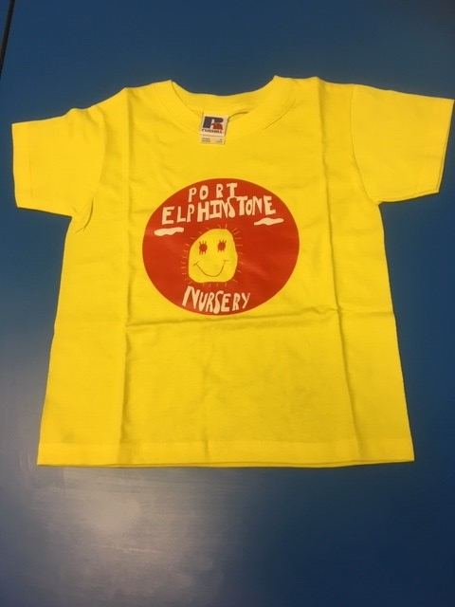

Policies

Copies of all nurseries aims, and policies can be found in folders in our foyer area for your perusal. Should you wish to have a copy of any of the policies then please let staff know.

Inspection Report

Port Elphinstone Nursery is a registered pre-school provider and is inspected regularly by the Care Inspectorate and also by Education Scotland. Copies of these reports are displayed by the noticeboard in the nursery reception area. Staff are available to discuss or explain these reports if necessary.

Complaints

It is your right to complain if you are not happy with any part of the services provided by Aberdeenshire Council. Please approach nursery staff or the Head Teacher in the first instance if at all possible. Alternatively refer to the complaints policy in the nursery foyer.

Child Protection Statement

Everyone has a responsibility to protect children from harm. School staff are in a unique position to contribute to the protection of children and must share concerns with appropriate colleagues and agencies.
Every school has a Designated Officer who has been specially trained to listen to concerns and act on them as necessary. At Port Elphinstone Primary School this is the Head Teacher, Mrs Amelia Davies.

Promoting Positive Relationships Policy

Rules are in place to ensure that all children enjoy a safe and stimulating environment where positive behaviour is promoted, and the children are encouraged to think of others as well as themselves.

Our nursery rules are to remind children to:
Always walk
Listen to others and use indoor voices
Share toys and look after them
Try to play safely and tidy away toys when finished playing
Keep their hands and feet to themselves
Be respectful of other children and adult’s feelings and their work
Be kind and helpful always

Why are these important?
• It is important to listen to each other and to adults.
• Children need to learn to negotiate sharing toys, games etc.
• Children need to help to keep themselves and others safe in the nursery by risk assessing situations and behaviour.
• Aggression is never acceptable behaviour and we will always try to support children to understand why they are feeling angry.
• Children need to care for and respect each other and their environment.

We will recognise when rules have been kept. We reward good behaviour by
• Giving verbal praise to every child who keeps the rules.
• Giving a reward ‘gem in the jar’ or a sticker to those who have been especially helpful.
• Giving a little well-done certificate (star of the day) after a period of helpful, sharing, caring behaviour.

In order to provide a safe, positive environment staff will:
Provide positive role models, show consideration, good manners and respect for all children and adults.
Understand stage/age appropriate behaviour and try to differentiate between deliberate and accidental occurrences.
Be consistent in the way we approach children, bearing in mind it is better to pre-empt a situation and avoid confrontation.

Please ask to see our Promoting Positive Relationships Policy for more information, if required.

We, the staff at Port Elphinstone Nursery, look forward very much to welcoming you and your child. This is a very important step for all children, and we will do our utmost to make the first years of their early learning and childcare experience enjoyable.

Term Dates 2022-23

The term dates for session 2022-23 are as follows:

Term 1 Tuesday, 23 August – Friday, 14 October 2022
Term 2 Monday, 31 October – Tuesday, 23 December 2022
Term 3 Wednesday, 9 January – Friday, 31 March 2023
Term 4 Monday, 17 April – Friday, 7 July 2023

Holidays

Monday, 13 February 2023
Monday, 1 May 2023

In Service Dates

Monday, 22 August 2022
Thursday, 17 November 2022
Friday, 18 November 2022
Tuesday, 14 February 2023
Wednesday, 15 February 2023

Please provide written confirmation of any intended prolonged absence from Nursery eg holiday, hospital stay or family circumstances.

